Causal Inference Practice 3
- Kentucky has implemented a job training program designed to help unemployed people find new jobs. You are hired to assess the causal effect of this program on the future employment outcomes of people that attend it.

You are able to convince the state government to randomly assign which unemployed people will be sent personalized mailers inviting them to attend the training.

One year later, you receive the following dataset:

Person ID | Invited to Training | Attended Training | Average Weekly Earnings  (1 year later)
1 | Yes | Yes | 300
2 | Yes | Yes | 500
3 | Yes | Yes | 900
4 | Yes | Yes | 1,000
5 | No | No | 300
6 | No | No | 400
7 | No | Yes | 600
8 | No | Yes | 1,200

- First Stage Effect Estimate

- Explain what the "first stage effect" refers to in this scenario.

- What regression specification would yield an estimate of the first stage effect?

- Calculate the first stage effect using the data above.

- Reduced Form Effect Estimate

- Explain what the "reduced form effect" refers to in this scenario.

- What regression specification would yield an estimate of the reduced form effect?

- Calculate the reduced form effect using the data above.

- IV Estimate

- Calculate the Instrumental Variables Estimate of the (Local) Average Treatment Effect using your answers in a)iii and b)iii.

- Is the exclusion restriction satisfied in this case? Explain.

- Find the estimate of $β$ that you would find by running the following regression
$y_{i}=α+βAttend_{i}+u_{i}$.

How does it compare to your IV estimate in c? What might explain this difference?

- A program in Georgia offers free tuition to high performing students that score at least 1400 on their SATs. As part of the state’s ongoing evaluation of the program the state tracked the SAT scores and later college enrollment status and adult earnings of all HS seniors in Georgia. Using this data the following two figures were compiled:

Figure 1: Each dot represents the fraction of Georgia HS seniors with the given SAT score that enrolled in college.
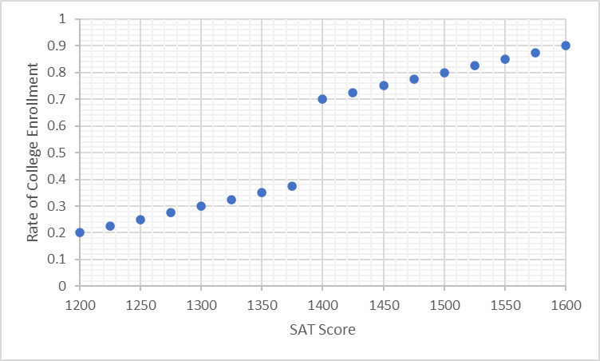

Figure 2: Each dot represents the average earnings at age 30 of Georgia HS seniors with the
given SAT score.
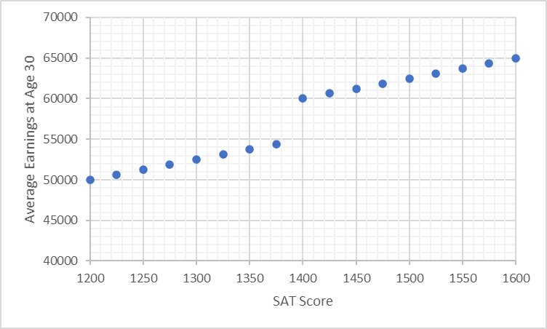0

- First Stage Effect Estimate

- Explain what the "first stage effect" refers to in this scenario.

- What regression specification would yield an estimate of the first stage effect?

- Calculate the first stage effect using the data above.

- Reduced Form Effect Estimate

- Explain what the "reduced form effect" refers to in this scenario.

- What regression specification would yield an estimate of the reduced form effect?

- Calculate the reduced form effect using the data above.

- IV Estimate

- Calculate the Instrumental Variables Estimate of the (Local) Average Treatment Effect using your answers in a)iii and b)iii.

